ENG5059P (MSc)

Student Name | Zhengye Li
Student GUID Number | 2615939L
Degree programme | ENG5059P: MSc Project
Working Title of Project | Understanding microbial ecology of granule flotation
Name of Supervisor(s) | Umer Ijaz
Academic year | 2021-2022

Introduction

The main idea of this paper is based on microbial ecology of granule flotation&R language.

Anaerobic digestion for biological waste water treatment is underpinned by development of active granular biofilms, which harbour microbial communities that convert organic pollutants to a methane-based biogas, for example, in up flow anaerobic sludge bed (UASB) bioreactors.

An inherent problem of these bioreactors is that granule flotation occurs which lead to washout of active granules that can dramatically results in underperformance of such systems.

In this project, 16S rRNA samples are available for laboratory-scale bioreactors that emulate UASB bioreactor, and for which both 16S rRNA and 16S rDNA datasets are available for floating and settled granules, along with performance parameters.

By using a combination of several methods and ecological frameworks, I can begin to piece together the dynamic process of flotation occurs in space and time under different environmental conditions. This method of controlling variables and 16S rRNA and 16S rDNA datasets can piece together a plausible assembly mechanism for microbial communities.

Therefore, my research focused on the assembly mechanisms of microbial communities.
Microbial community assembly is shaped by both deterministic and stochastic ecological processes. The deterministic and stochastic ecological processes are based on the analysis of anaerobic digestion in biological wastewater treatment mentioned above.

Finally, the cross-sectional differences between the above different types of samples

Aims/Objectives of project

1.Understanding microbial ecology of granule flotation.

2.Understanding the cross-sectional differences between the above different types of samples by employing recent analytical tools, particularly those focused on the assembly mechanisms of microbial communities."

Resources required

sorting | Resources required | time
1 | R language | Long
2 | Biological knowledge | Mid
3 | Analytical tool learning | Mid
4 | Data set | short
5 | The literature | long

GANTT chart

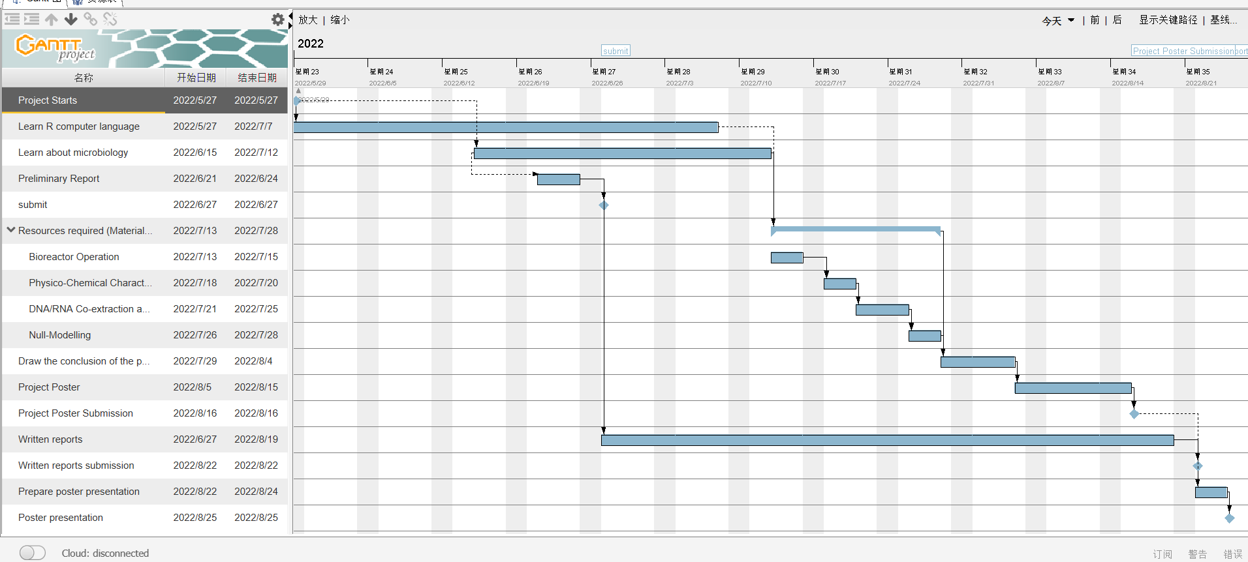

Risk assessment
